

|  |
| --- |
| KULLIYAH OF INFORMATION & COMMUNICATION TECHNOLOGY  DEPARTMENT OF COMPUTER SCIENCE  SEMESTER I, 2015/2016 |

CSC 1103 OBJECT-ORIENTED PROGRAMMING

GROUP PROJECT

**SWIFT ADDRESS**

**Team members:**

**Hasan Tanveer Mahmood 1725413  
K M Zubair 1722931**

**K M Tansir Hussain 1638331  
Mufida Zuhrah Binti Zulhendri 1723396**

**Hanan Haidar Alattas 1624552**

**Submission Date: 5th May 2019**

**Table of Content**

1. Project Description 2

2. Project Organization 2

3. Methodology 2-13

3.1. Analysis 2

3.2. Design 3

3.3. Development 5

3.4. Testing 13

3.5. Implementation 14

4. Conclusion 14

References 14

Appendix 14

# Project Description

Swift Address is a desktop application which is designed for the sole purpose of keeping track of the user’s contact list and their contact details. Individually, a user is allowed to add, delete and update contacts from his account. It has multiple user option consisting of different data set for the users of different need and of different taste. It also has the real time search option and instant login logout option. Yes of course the user can sign up or reset forgotten password by using pin code that was being registered during the sign up procedure.

# Project Organization

Hasan Tanveer Mahmood

**Project Manager**

K M Zubair

**Project Planner**

K M Tansir Hussain

**Software Testing Loader**

Mufida Zuhrah Binti Zulhendri

**Business analysis**

Hanan Haidar Alattas

**Project Designer**

# Methodology

## Analysis

The Functional requirements of our project are:

1. Users must have to limit their contact list to not more than 1000 and accounts up to 5 only.
2. Users must validate their login data by themselves.
3. Users cannot change password without valid pin number which he registered while signing up.
4. While inserting user name or password, no space is allowed.
5. While creating contact, the character ‘|’ will cause the program to possess unexpected output.
6. The user can’t sign up if the username or phone number is already registered before.

## Design

* Our program creates and uses individual text file to store credential and contact list.
  1. **GUI Screen shot**

1. **A screenshot of a cell phone

   Description automatically generatedUser Login Interface :**
2. **Login Existing user :**

1. **Something Is Missing :**

1. **User Name Already Exist :**

1. **A screenshot of a cell phone

   Description automatically generatedA screenshot of a cell phone

   Description automatically generatedPassword Doesn’t Match :**
2. **Create a New User :**
3. **New User Login :**

1. **New User Interface :**

1. **A screenshot of a cell phone

   Description automatically generatedAdd New Contact : (**You must fill all the field otherwise it shows red border)
2. **All The Field Were Fill Upped That’s Why It Shows Green Border :**

1. **A screenshot of a cell phone

   Description automatically generatedA Contact Added Successfully :**
2. **Now Contact is Added In User Diary :**

1. **A screenshot of a cell phone

   Description automatically generatedAdd Another New Contact : ( Show Alert Message )**
2. **Another Contact Added Successfully :**

1. **Delete Contact Option : ( A confirmation message will show )**

1. **A screenshot of a cell phone

   Description automatically generatedContact Deleted From user Diary :**
2. 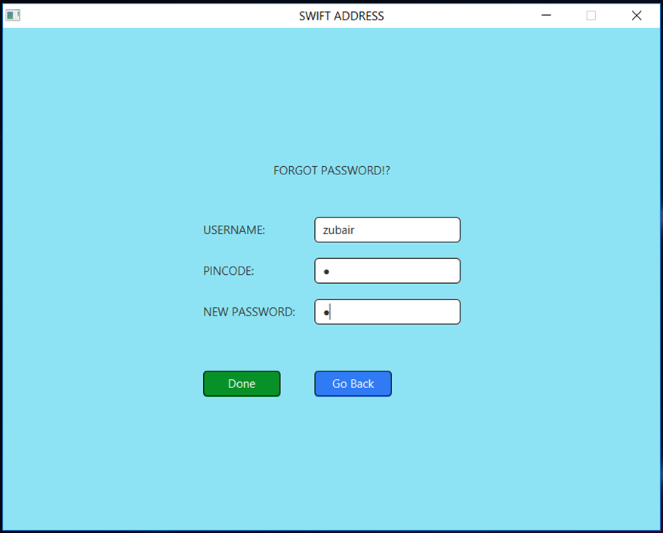**Reset Password Option :**
3. **Search Option : (Consider Uppercase Lower Case) :**

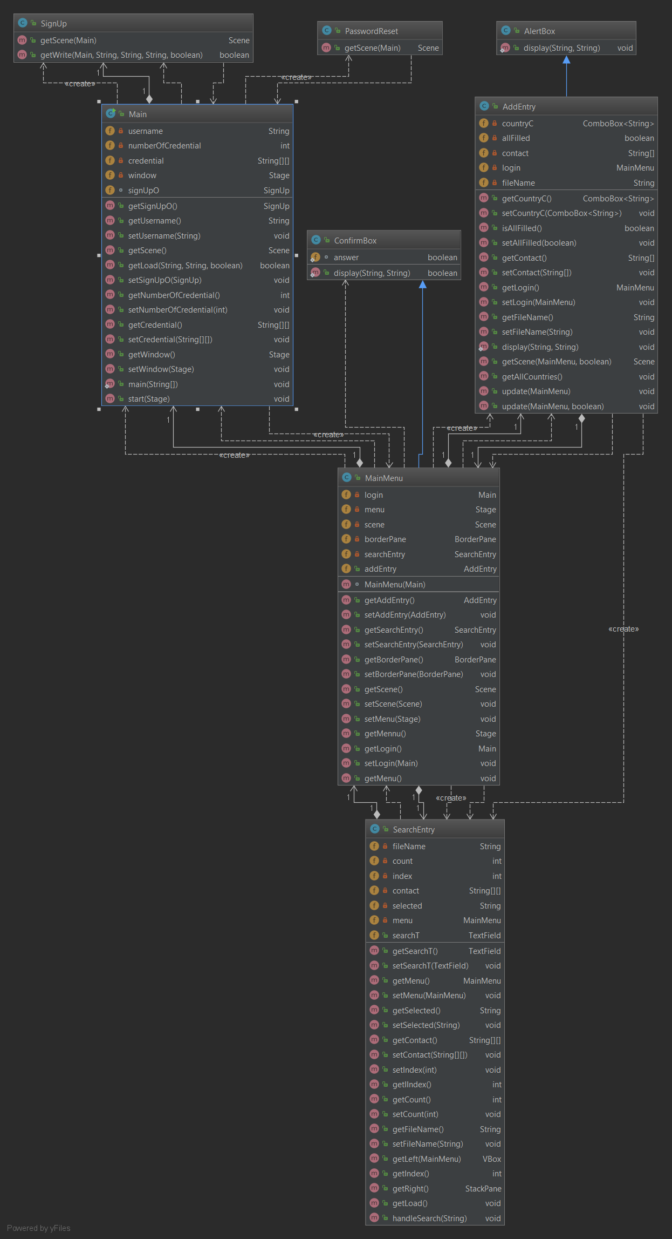

**3.4 UML Class Diagram**

# Conclusion

# As a future improvement, we will be wanting to add the following features:

* Well structured and easily maintainable database to store and process the data
* Cloud back up service
* Image attribute for contact list
* User friendly interface and Portability
* Instant call or chat system over the internet
* Getting contact details directly on mobile operator through message. (Subscription fee might occur)
* Syncing contact details from cloud to device after loggin in for offline access.
* Launching social media adding buttons in the contact details section.

# References

* **For any kind of help or complaint regarding bug or vulnerability issue please contact us through this mail :**

**Email :** [**tanveer.mahmood2489@gmail.com**](mailto:tanveer.mahmood2489@gmail.com)

**Or**

**Email : contactkmzubair@gmail.com**